**Database name: Pizza DB**

**Table name: Pizza_sales**

use [Pizza DB]

select * from pizza_sales

**A. KPI Requirements:**

**1.Total Revenue:**

sum of total price

select sum(total_price) as Total_Revenue from pizza_sales

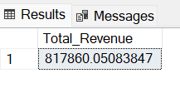

**2.Average order value:**

Total revenue / total number of orders

select sum(total_price)/count(distinct order_id) as Avg_order_value from pizza_sales

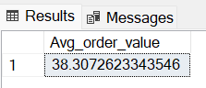

**3.Total pizzas sold:**

Sum of quantities of all pizzas

select sum(quantity) as Total_pizzas_sold from pizza_sales

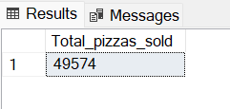

**4.Total orders:**

Count of unique order id’s

select count(distinct order_id) as Total_Orders from pizza_sales

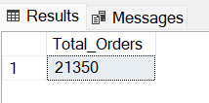

**5.Avarage pizzas per order:**

Sum of quantities / count of unique orders

select cast(cast(sum(quantity) as decimal(10,2)) / cast(count(distinct order_id) as decimal(10,2)) as decimal(10,2))

as Avg_pizzas_per_order

from pizza_sales

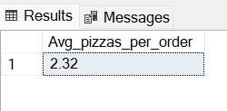

**B. Charts Requirements:**

**1.Daily trend for total orders:**

count of total orders by weekdays

select DATEPART(dw,order_date) as Day_Number,DATENAME(dw,order_date) as Order_Day, count(distinct order_id) as Total_Orders

from pizza_sales

group by DATENAME(dw,order_date),DATEPART(dw,order_date)

order by DATEPART(dw,order_date)

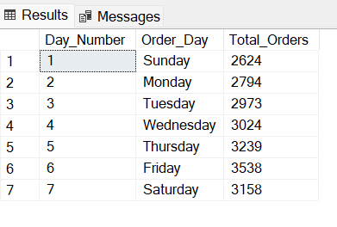

**2.Hourly trend for total orders:**

Total orders by Hours

select DATEPART(hour,order_time) as Order_Hour, count(distinct order_id) as Total_Orders

from pizza_sales

group by DATEPART(hour,order_time)

order by DATEPART(hour,order_time)

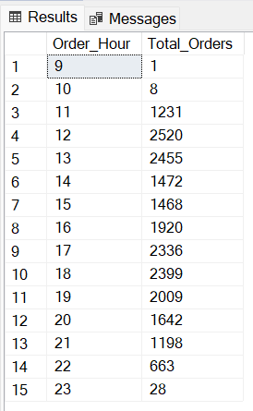

**3.Percentage of sales by pizza category:**

% of sales (total price) for each category by Pizza category

select pizza_category as Category,

cast(cast(sum(total_price)* 100 as decimal(10,0))/(select cast(sum(total_price) as decimal(10,2)) from pizza_sales) as decimal(10,2))

as Percentage_of_sales

from pizza_sales

group by pizza_category

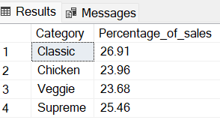

**4. Percentage of sales by pizza size:**

% of sales (total price) for each pizza size by Pizza sizes

select pizza_size as Category,

cast(cast(sum(total_price)* 100 as decimal(10,0))/(select cast(sum(total_price) as decimal(10,2)) from pizza_sales) as decimal(10,2))

as Percentage_of_sales

from pizza_sales

group by pizza_size

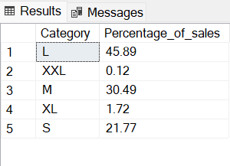

**5.Total pizzas sold by pizza category:**

Total pizzas sold (sum of quantity) by Pizza category

select pizza_category as Category, sum(quantity) as Total_Pizzas_Sold from pizza_sales

group by pizza_category

order by sum(quantity) desc

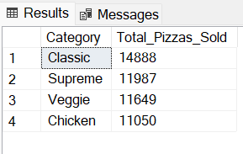

**6.Top 5 best sellers by total pizzas sold:**

Top 5 pizza sellers name wrt quantity

select top 5 pizza_name as Seller_Name,sum(quantity) as Number_of_pizzas_sold

from pizza_sales

group by pizza_name

order by sum(quantity) desc

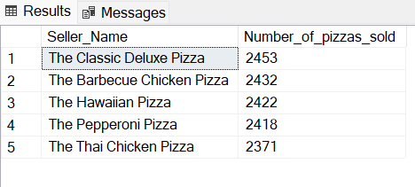

**7.Bottom 5 worst sellers by total pizzas sold:**

Bottom 5 pizza sellers name wrt quantity

select top 5 pizza_name as Seller_Name,sum(quantity) as Number_of_pizzas_sold

from pizza_sales

group by pizza_name

order by sum(quantity) asc

